**Submitted to:**

Dr. Raheel Ahmad Memon

**Smart Plant Monitoring System Using NodeMCU and ThinkSpeak**

**By:**

Shah Muhammad

Sajjad Hussain

Akhlaq Ali

Kamran

**Circuit Diagram:**

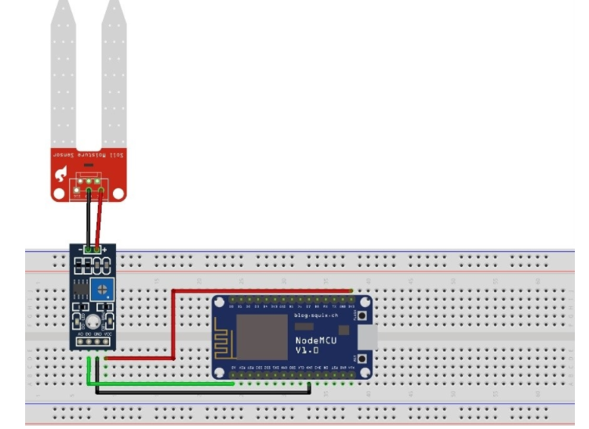

**Results Showing on Think Speak:**

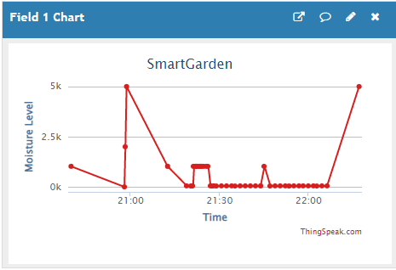

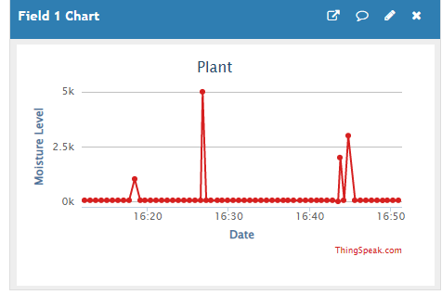

**Sensor values in serial monitor**

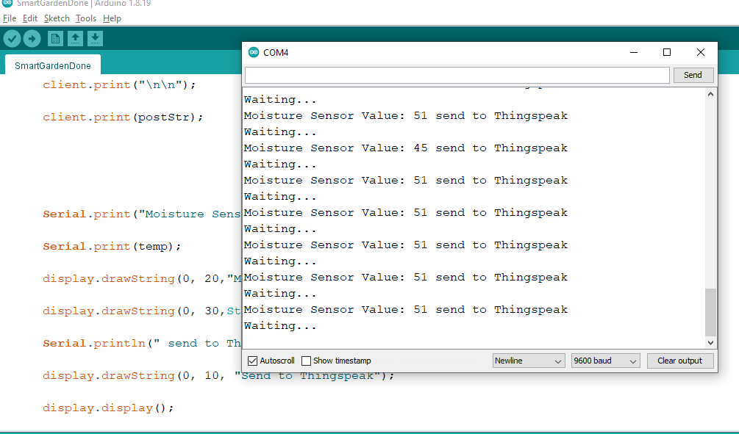

**Brief Introduction and Overview:**

Plant plays a vital role in maintaining the ecological cycle and forms the foundation of a food chain pyramid and thus to maintain the plant’s proper growth and health adequate monitoring is required. Hence the aim at making plant monitoring system smart is using automation and Internet of Things (IOT) technology. This topic highlights various features such as smart decision making based on soil moisture real time data.

The computerized water system framework with IOT is practically and financially sufficient for planning water resources for plantation of plants. Adopting the automatic water system framework, we can demonstrate that the utilization of water can be decreased for various plantations usages. The system framework has an appropriated microwaves (wireless) chain of moisture content in the soil through soil moisture sensor set in the root zone of the plants. The data will gather from the sensors and send to the web server (cloud (ThinkSpeak)).

The aforementioned points highlight the study of IOT in the field of agriculture. This shows how we can implement the IOT technology to make our planting smart and reliable with the real time updated data.

**Interpretation of the sensor value:**

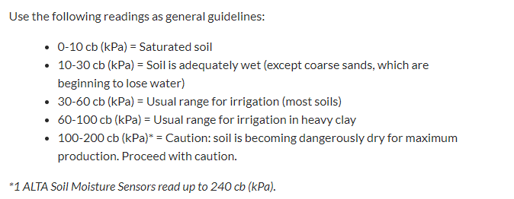

We converted the value coming from the sensor to the percentage and it will show us the result in the percentage on the serial monitor and on the think speak server.

**CONECTIVITY TO IFTTT:**

We also connected the think speak to the IFTTT website which will read data from the think speak server and will send the email to the given email when certain threshold is met. The threshold we have set for the sending notifications/emails is 10. When the moisture level is decreased then 10%, it will send the email to the specified email.

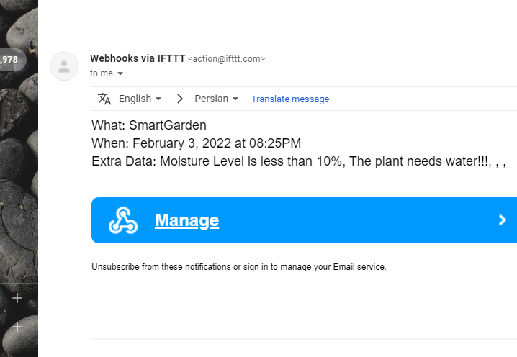

**Email from IFTTT**